**Air University**

**Final Semester Examination Fall**

**Student Id:__210705_______**

**Subject:- System and Network Administration Lab Total Marks:- 50**

**Course Code:- IT-360L Date:- Wednesday, 04 January, 2024**

**Class:- BSIT Time:- 2:00pm**

**Semester:- 5th Semester Max Time Allowed: 3 hrs 00 mins**

**Section(s):- A**

**FM(s) Name:- Yasir Ali**

**FM Signature:**

**You have already installed Microsoft Server operating system for administration tasks. You need**

**to configure your active directory with following policies.**

**1. Create a new tree having all its primary components.**

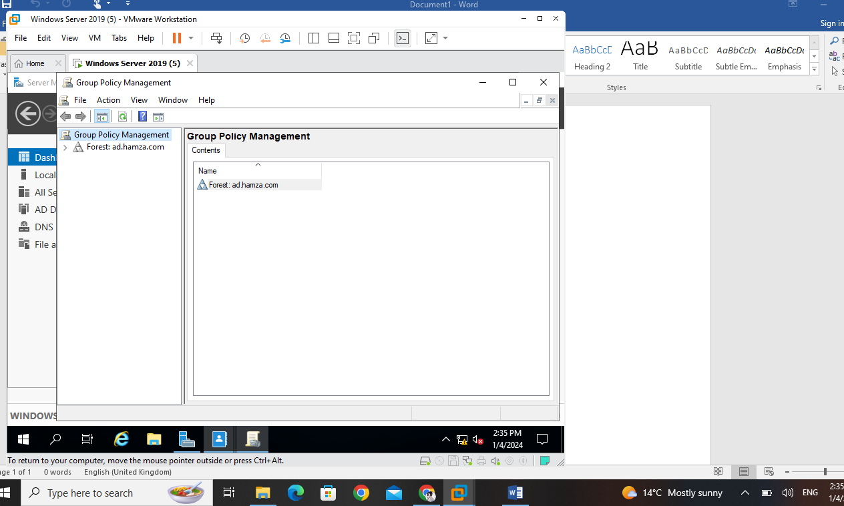

**Create a policy for enabling a specific website and disable its inheritance for all the**

**components in the forest.**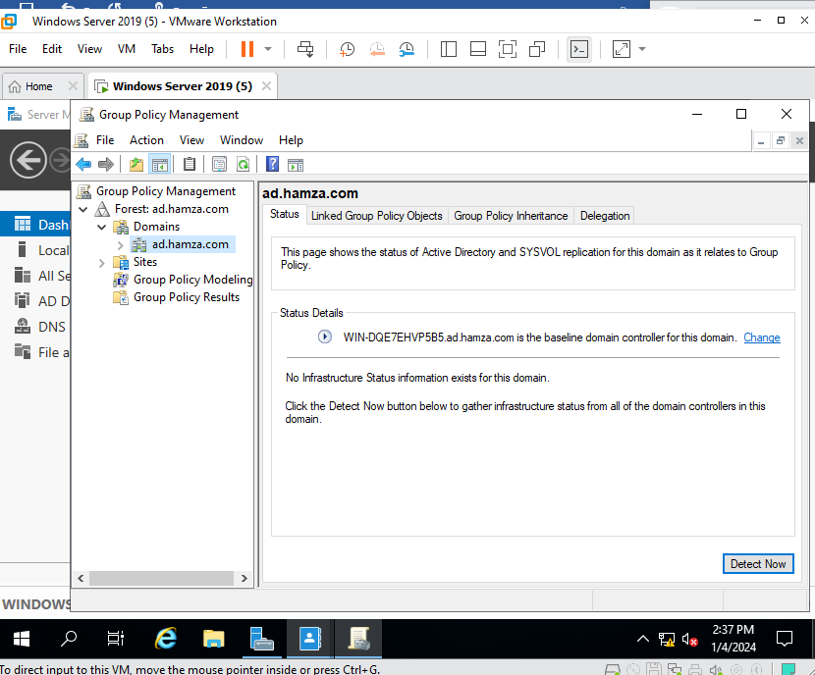

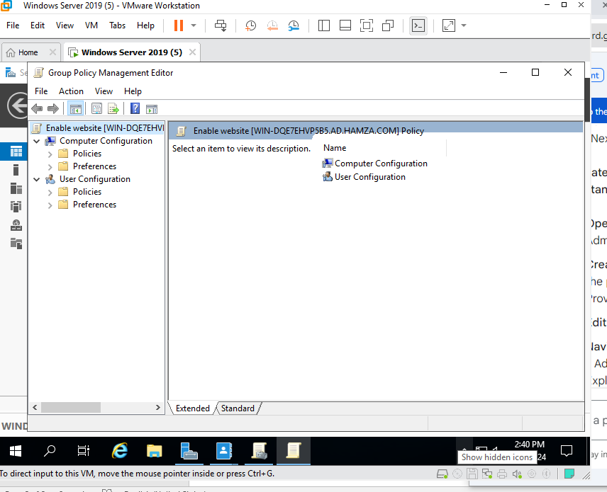

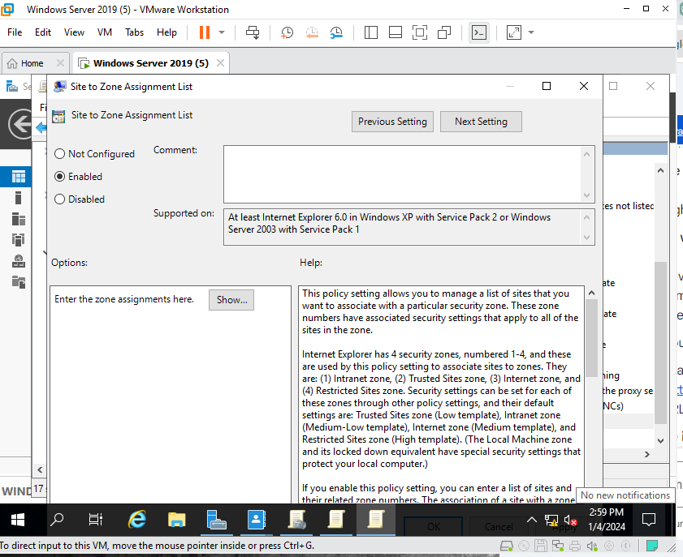

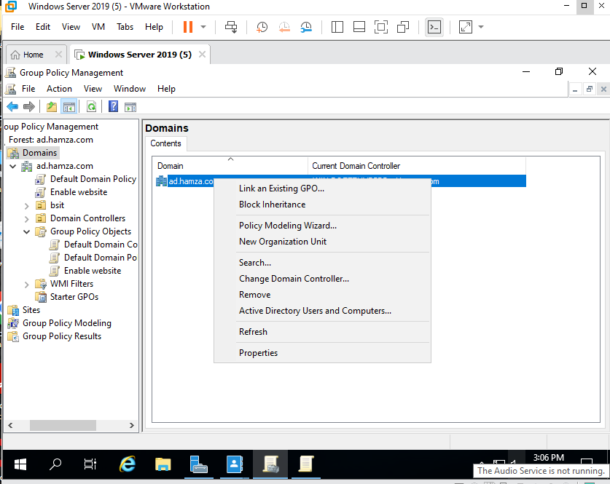

**Create 2 groups. Now redefine the group policy where 2 domains have 2 different**

**policies and the policy does not work cross domain.**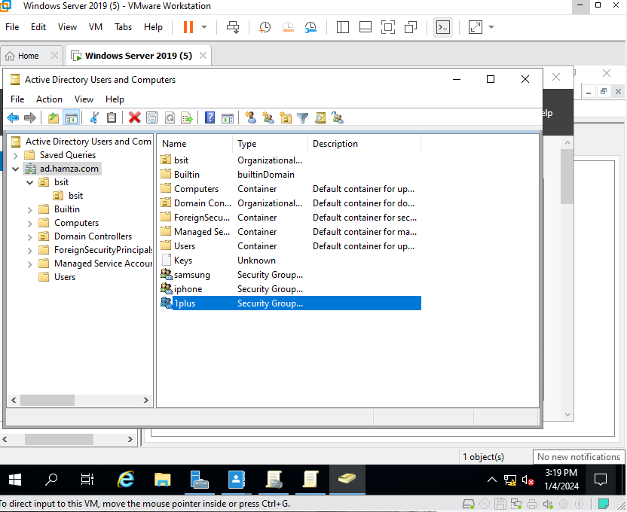

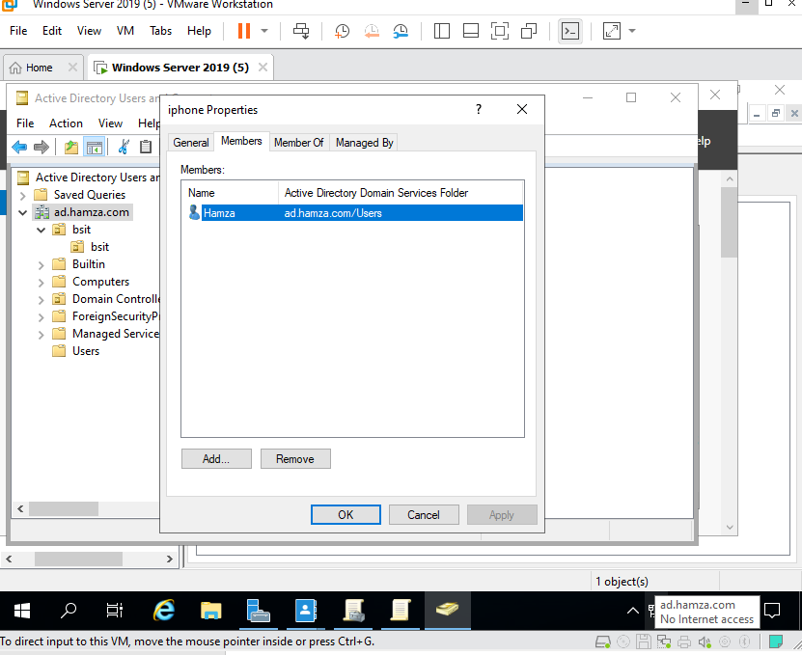

**Temporarily override the group policy so it can work in both domains.**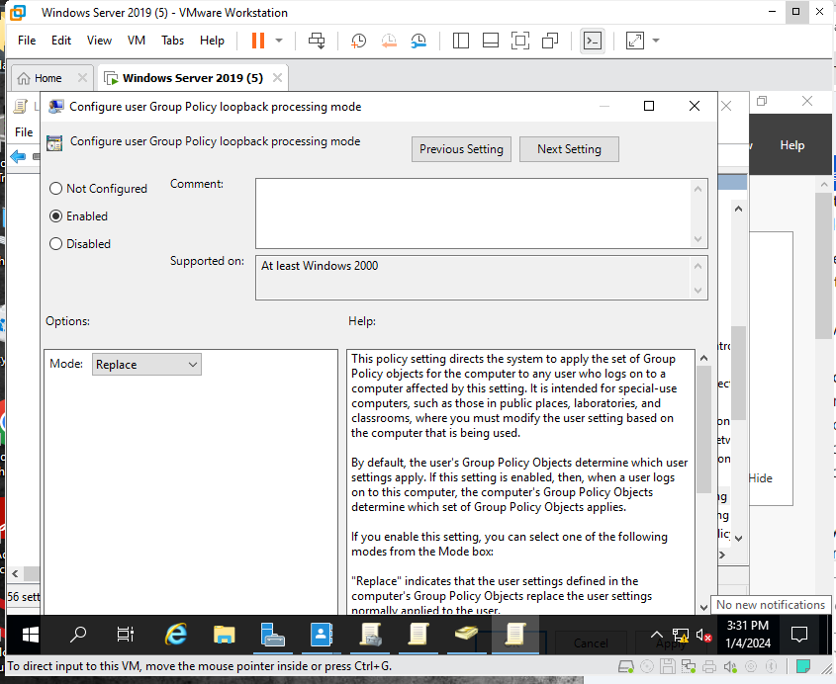

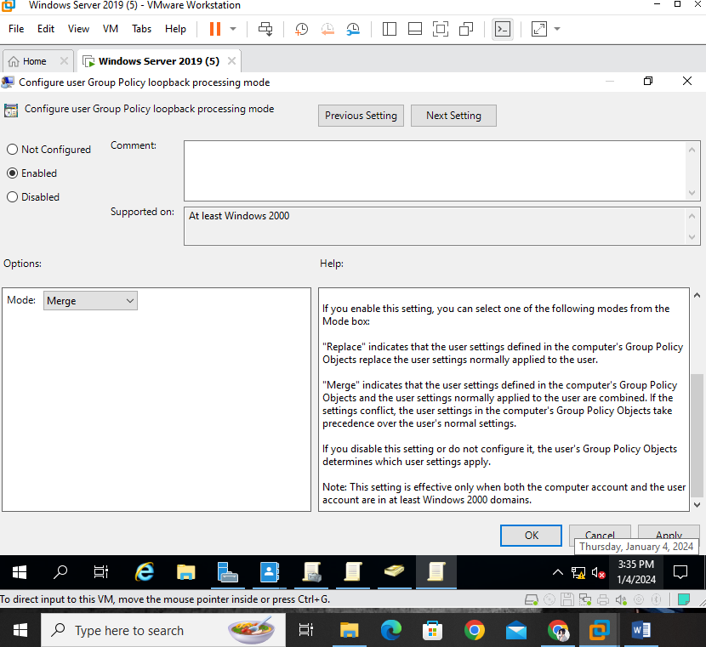

**Add any performance optimization technique on your project.**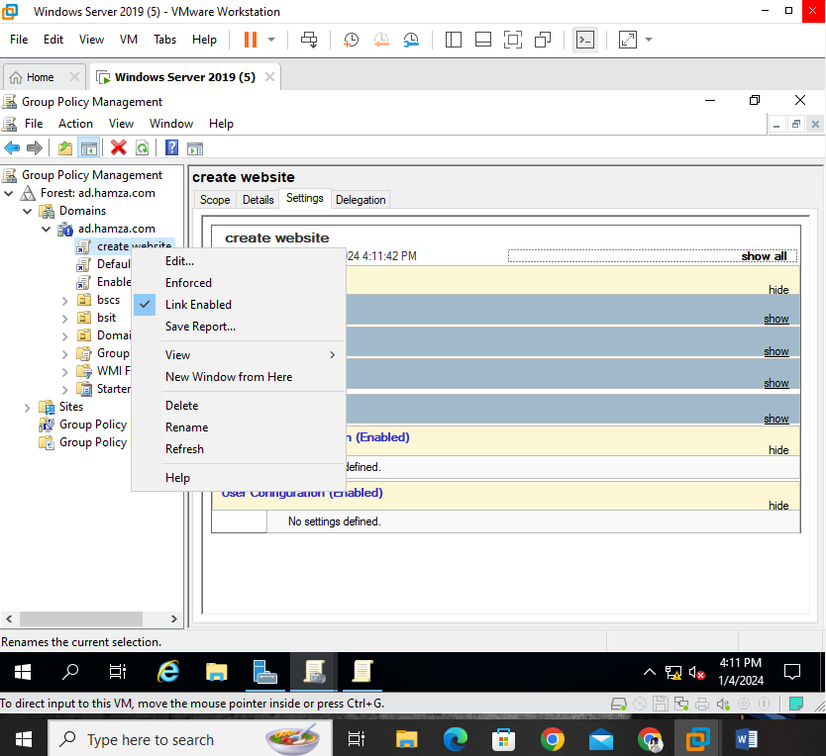

**Here are some easy performance optimization techniques for a Windows Server domain:**

**Adjust Visual Effects:**

